

**TRỌ FINDER**

**Software Requirement Specification**

– Hanoi, May 2023 –

**Record of changeS**

|  |  |  |  |
| --- | --- | --- | --- |
| **Date** | **A* M, D** | **In charge** | **Change Description** |
| 13/Apr | A | KienNT | Thêm mô tả chức năng Setting Details (II.1.a) |
|  |  |  |  |
|  |  |  |  |
|  |  |  |  |
|  |  |  |  |
|  |  |  |  |
|  |  |  |  |
|  |  |  |  |
|  |  |  |  |
|  |  |  |  |
|  |  |  |  |
|  |  |  |  |

*A - Added M - Modified D - Deleted

**Table of Contents**

**I. Overview 5**

1. Introduction 5

2. System Functions 6

a. Screen Flow 6

b. Screen Details 6

c. User Authorization 6

d. Non-Screen Functions 7

3. Entity Relationship Diagram 7

**II. Functional Requirements 8**

1. <<Feature Name 1>> 8

a. <<Function Name 1>> 8

b. <<Function Name 2>> 8

2. <<Feature Name 2>> 8

# I. Overview

## 1. Introduction

This project aims to develop a system to find accommodation and activities for students around Hoa Lac area. The accommodation search application allows customers to easily search for the right room for their needs with just a few simple steps. Users can customize search criteria such as location, price, area, amenities, .. The application provides detailed information about the room including photos, amenities, owner contact information. room,...

This system supports the following types of users:

**Web skeleton -> [Link](https://miro.com/app/board/uXjVMJclHc4=/)**

• Customers: viewers

• Sales : sales members of the organization

• Admin: the leader/manager of the organization, acting as the system administrator

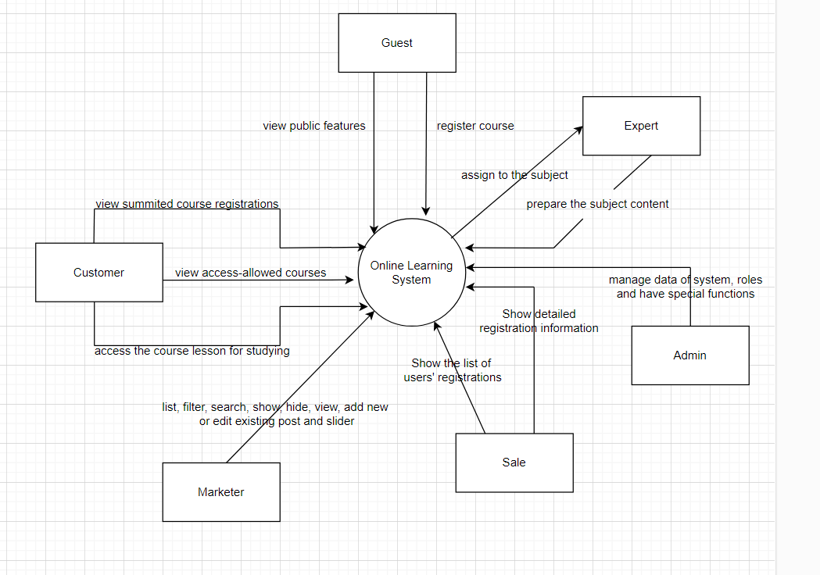

## 2. System Functions

#### a. Screen Flow

1. *Guest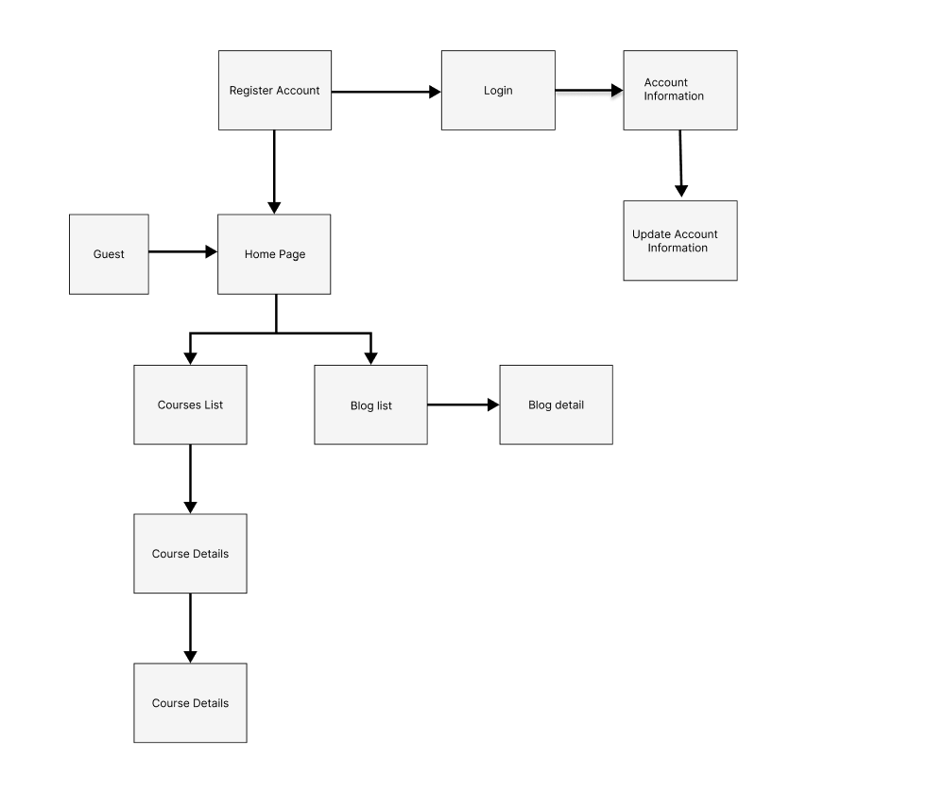*
2. *Customer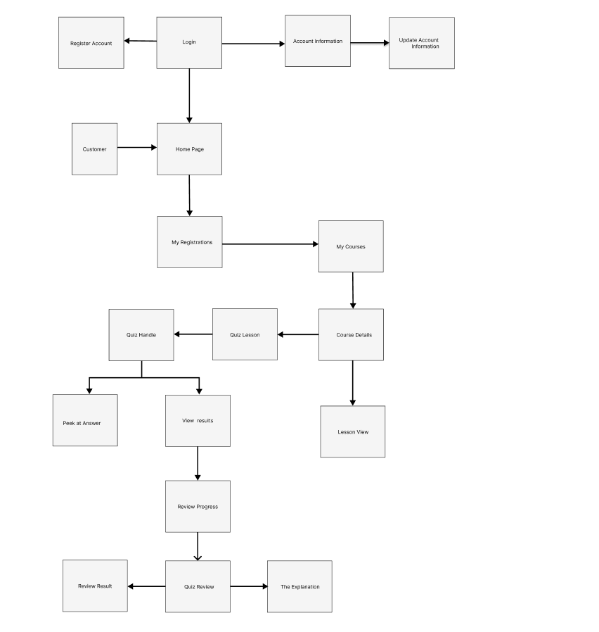*
3. *Marketing*

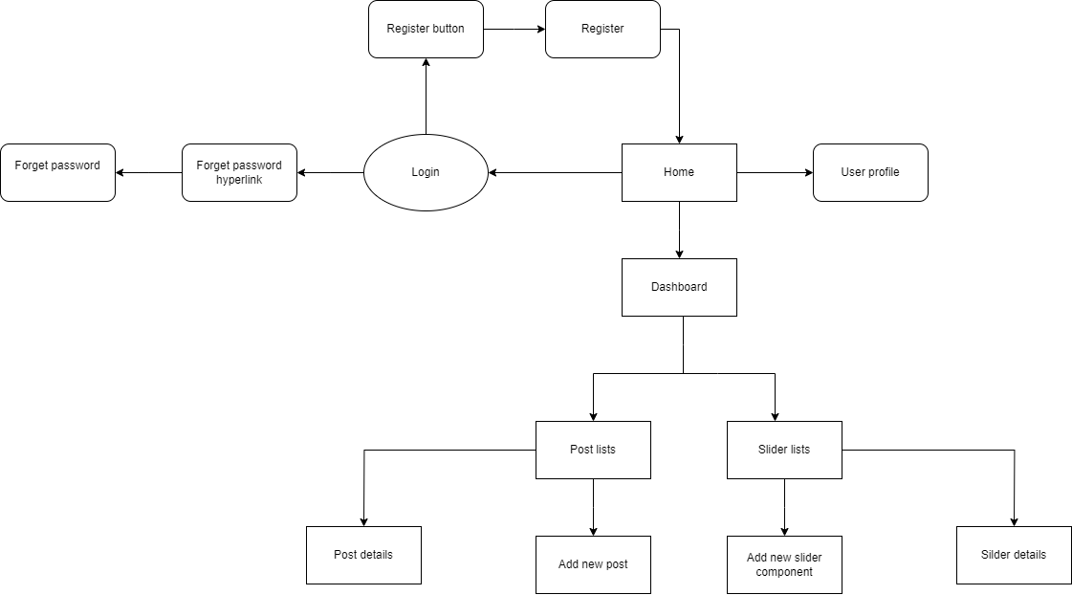

1. *Sale*

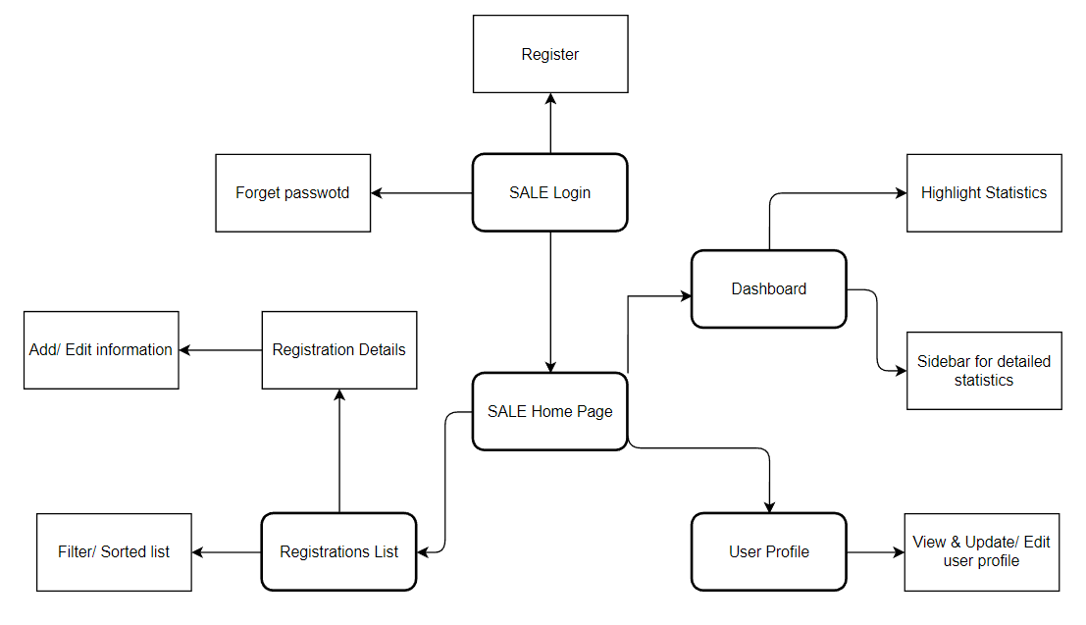

1. *Expert*

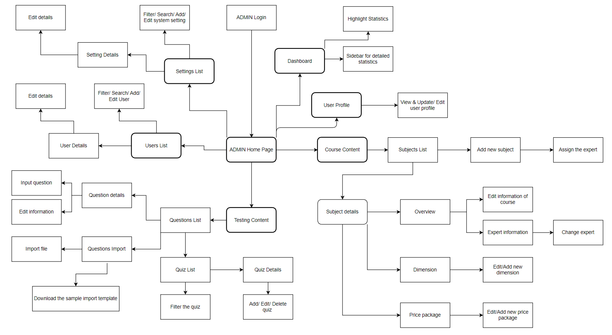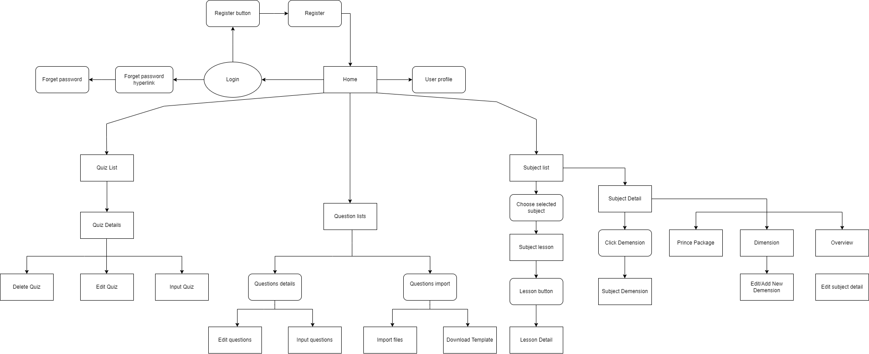

1. *Admin*

#### b. Screen Details

|  |  |  |  |
| --- | --- | --- | --- |
| # | Function/Screen | Feature | Function/Screen Details |
| 1 | User Login | Common | This is a pop-up screen which allows the user to enter email & password to login; on this page, there are also options for user to register new information or reset the password for the case user forget it. |
| 2 | User Register | Common | This is a pop-up screen which allows the user to register himself/herself to the system by inputing following information: full name, gender, email, mobile; User then need to verify by clicking the link sent via email to him/her before being able to access the system |
| 3 | Reset Password | Common | The user input his/her email to receive the reset password link. This link is sent to the user's email for his/her password resetting.  - On clicking the link, the user is redirected to the password resetting page in which s/he input new password (twice) for the system access  - Note that the link is only available for a specific time duration as configured in the system config file. |
| 4 | User Authorization | Common | Implementation of authorization mechanism in the system, including the specify the role of logged-in user, his/her authorized page links (building the displayed menu items (in the front end) and preventing unauthorized access via enter the links directly) |
| 5 | User Profile | Common | This is a pop-up screen which allows the user to edit his/her profile information, including the registered ones & the avatar image. Please note that s/he is not allowed to change the email |
| 6 | Change Password | Common | This is a pop-up screen which allows the user to change his/her password by inputting his current password as well as new password (twice) |
| 7 | Home | Public | Show sliders, hot posts, featured subjects + the slider with the latest posts, static contacts/links  - Shown slider information includes its image and title; the user is redirected to the slider's backlink on his/her clicking  - Shown post information includes its thumbnail, title, post date; the user is redirected to the post's details on his/her clicking  - Shown subject information includes its thumbnail, title, tag line; the user is redirected to the subject's details on his/her clicking |
| 8 | Blogs List | Public | Show the posts paginatedly (sorted by updated date) + the slider with the post search box, posts categories, latest posts, static contacts/links; Shown post information includes its thumbnail, title, category, brief-info; the user is redirected to the post's details on his/her clicking |
| 9 | Blog Details | Public | Show post details (including title, author, updated date, category, and post details) + the slider with the post search box, posts categories, latest posts, static contacts/links |
| 10 | Subjects List | Public | Show the subjects paginated (sorted by updated date, paginated) + the sider with the subject search box, subject categories, featured subjects, and static contacts/links;  - Shown subject information includes its thumbnail, title, tag line, lowest price package option (list price, sale price);  - The user is redirected to the subject's details on his/her clicking on the subject  - The user can choose to register to the subject by clicking the Register button |
| 11 | Subject Details | Public | Show subject details (including title, tag line, brief info, lowest price package option (original price, sale price), product description, and a Register button) + the sider with the subject search box, subject categories, featured subjects, static contacts/links |
| 12 | Subject Register | Public | This is a pop-up screen which allows the user to register for access to a subject. On this screen, the user needs to choose appropriate subject price package & input his/her information (full name, email, mobile, gender); A logged in user doesn't have to input those contact information |
| 13 | My Registrations | Customer | Show the list of user's registrations + the sider with the subject search box, subject categories, static contacts/links  - Each registration includes below information: id, subject, registration time, package, total cost, status, valid from, valid to;  - If the registration is still in the submitted status, the users can choose to cancel it or coming back to the Subject Register pop-up to edit it) |
| 14 | Practices List | Customer | This page allows the user to view the list of quiz practices that s/he has taken |
| 15 | Practice Details | Customer | This page allows the user to input new practice information for practicing or to view his/her existing one |
| 16 | Simulation Exams | Customer | This page allows the user to view the existing exams of the subject that s/he has the access to.  • List columns: id, subject, simulation exam, level, #question, duration, and pass rate  • The user can filter the list by the subject + search list items by the exam name  From the list, the user can choose to take the exam to see the exam details, and then to go to the Quiz Handle page to practice that relevant simulation exam. |
| 17 | Quiz Handle | Learning | This screen allows the user to browse and answer the quiz questions |
| 18 | Quiz Review | Learning | This screen allows the user to review the details of the quiz that s/he has just taken |
| 19 | Dashboard | Marketing | Show statistics of new subjects (new, all), new registrations (success, canceled, submitted), revenues (total, by subject categories), customers (newly registered, newly bought), and the trend of order counts (success, all) by day for the last 7 days (the start date & end date can be adjustable) |
| 20 | Post Details | Marketing | Show detailed post information (thumbnail, category, title, brief information, description, flag to turn the featurning on/off, status), from that allow the user to input, view or edit them |
| 21 | Sliders List | Marketing | Show the paginated list of sliders (including sliders' id, title, image, backlink, status)  - The user can filter the sliders by the status + search by title or backlink  - For each slider, the user can choose to hide, show, edit it |
| 22 | Slider Details | Marketing | Show detailed slider information (image, title, backlink, status, notes) |
| 23 | Subjects List | Course Content | Show the list of course paginatedly. The shown information for each subject include the id, name, category, number of lessons, owner, and status  The user can:  - Filter the list by course category & status  - Search the course by the name  - Choose to add new course (redirect the user to the New Subject page for that)  - Edit course information (linked to the Subject Details for that) |
| 24 | New Subject | Course Content | The screen is shown with below information for the user to input new course information: name, thumbnail image, category, featured flag, owner, status, and description |
| 25 | Subject Details | Course Content | This page allows the admin and the assigned expert to access and prepare the subject information, including the course general information, the dimension, and price package. Only the admin can change the status to Published or Unpublished + add/edit the price packages |
| 26 | Subject Dimension | Course Content | This page allow the admin/expert to input or edit subject dimension information, including the following detailed information: type, name, description |
| 27 | Price Package | Course Content | This page allows the admin to input or edit subject dimension information, including the following detailed information: name, access duration (in months), status (read-only), list price, sale price, description. The expert can only view the information. |
| 28 | Subject Lessons | Course Content | This page shows the list of lessons for a selected package. On this page, the admin/expert is allowed to activate/deactivate, or call the Lesson Details for adding new or editing existing lesson |
| 29 | Lesson Details | Course Content | This page allows the admin/expert to input/edit the lesson information |
| 30 | Questions List | Test Content | The existing questions list for a specific subject/course are shown here (paginatedly). On this screen, the admin/expert is allowed to filter the questions by the subject, lesson, dimension(s), level, status + search the questions by content  Below information is shown for each question in the list: id, content, subject /dimension /lesson, level, status + options to show, hide, edit it; The page also allows the user to import the question (redirect him/her to the Questions Import pop-up screen. |
| 31 | Question Details | Test Content | This page allows the admin/expert to input or edit questions information, including following information: subject, dimension(s), lesson, status, content, media (image, audio, video – with preview option), answer options (with the key marked + ability to add, edit, delete), and explanation |
| 32 | Question Import | Test Content | This is a pop-up screen which allows the user to choose the import file and then import the questions in the file into the questions bank. The screen also provides the option for the user to download the sample import template. |
| 33 | Quizzes List | Test Content | The existing quizzes are shown in this page paginatedly:  - The user can filter the list by subject, quiz types + search quizzes by the name  - Each quiz includes following information: id, name, subject, level, # question, duration, pass rate, and the quiz type.  From this page, the user has the option to call to the Quiz Details page for adding new or editing existing quiz + delete the quiz. Please note that the quiz can be edited only when there is not any test taken yet. |
| 34 | Quiz Details | Test Content | This page allows the user to input or edit quiz information |
| 35 | Registrations List | Sale | Show the list of users' registrations  - Each registration includes below information: id, email, registration time, subject, package, total cost, status, valid from, valid to, last updated by;  - The user can filter the list by subject (searchable), registration time (from, to), status + can search by the email  - The list can be sorted by id, email, registration time, subject, package, total cost, status, valid from, valid to  - From the list, the user can choose to add new or edit an existing registration via the Registration Details screen as below |
| 36 | Registration Details | Sale | Show detailed registration information (subject, package with list price/sale price, full name, gender, email, mobile), registration time, sale, status, valid from, valid to, notes) from that for the user to add new or change the status of a registration with relevant notes (if a registration is created by the user, then s/he can edit other registration information). On changing a registration status to Paid, if the user with relevant registered email does not exist, the system would create one and send back to the user the login information (link, email, pass) along with the other notification notes |
| 37 | Users List | Admin | Show the paginated list of registered users (include users' id, full name, gender, email, mobile, role, status):  - The admin can filter the users by gender, role, status  - Allow the admin to search users by full name, email, mobile  - The list is sortable by id, fullname, gender, email, mobile, role, status  - From each user, the admin can choose to view or edit it  - The page also have the button/link that allows the admin to add new user |
| 38 | User Details | Admin | Show detailed user information (avatar, full name, gender, email, mobile, role, address, status), from that allow the user to add new, view or edit user information  - After adding, new generated login password would be email to the new user  - The admin can only edit/update the role and status of the user |
| 39 | Settings List | Admin | Show the paginated list of settings (include settings' id, type, value, order, status):  - The admin can filter the setting by type, status  - Allow the admin to search settings by value  - The list is sortable by id, type, value, order, status  - From each setting, the admin can choose to view, activate/deactivate, or edit it  - The page also have the button/link that allows the admin to add new setting |
| 40 | Setting Details | Admin | Show detailed user information (type, value, order, description, status), from that allow the user to add new, view or edit setting information |

#### c. User Authorization

| **Screen** | **Guest** | **Customer** | **Marketing** | **Sales** | **Expert** | **Admin** |
| --- | --- | --- | --- | --- | --- | --- |
| **Common Feature** | | | | | | |
| <<Login screen>> | X | X | X | X | X | X |
| <User login> | X | X | X | X | X | X |
| <User Register> | X |  |  |  |  |  |
| <Reset Password> |  | X | X | X | X | X |
| <User Authorization> |  | X | X | X | X | X |
| <User Profile> |  | X | X | X | X | X |
| <Change Password> |  | X | X | X | X | X |
| **Public Feature** | | | | | | |
| <Home Page> | X |  |  |  |  | X |
| <Blogs List> | X |  |  |  |  | X |
| <Blog Details> | X |  |  |  |  | X |
| <Courses List> | X |  |  |  |  | X |
| <Course Details> | X |  |  |  |  | X |
| <Course Register> | X |  |  |  |  | X |
| **Customer Feature** | | | | | | |
| <<My Registrations>> |  | X |  |  |  | X |
| <view submitted course registrations> |  | X |  |  |  | X |
| <<My Courses>> |  | X |  |  |  | X |
| <view access-allowed courses> |  | X |  |  |  | X |
| <<Lesson View>> |  | X |  |  |  | X |
| <access the course lessons for his/her studying> |  | X |  |  |  | X |
| <<Quiz Lesson>> |  | X |  |  |  | X |
| <take the topic quiz or view the quiz results> |  | X |  |  |  | X |
| <<Quiz Handle>> |  | X |  |  |  | X |
| <Peek at Answer button> |  | X |  |  |  | X |
| <Review Progress> |  | X |  |  |  | X |
| <Score Exam> |  | X |  |  |  | X |
| <<Quiz Review>> |  | X |  |  |  | X |
| <The Explanation> |  | X |  |  |  | X |
| <Review Result> |  | X |  |  |  | X |
| <Question Review> |  | X |  |  |  | X |
| **Marketing Feature** | | | | | | |
| <Dashboard> |  |  | X | X |  | X |
| <Post List> |  |  | X |  |  | X |
| <Post Details> |  |  | X |  |  | X |
| <Sliders List> |  |  | X |  |  | X |
| <Slider Details> |  |  | X |  |  | X |
|  |  |  |  |  |  |  |
| **Course Content** | | | | | | |
| <<Subjects List>> |  |  |  |  | X | X |
| <See all courses> |  |  |  |  |  | X |
| <Expert> |  |  |  |  | X |  |
| <<New Subjects>> |  |  |  |  |  | X |
| <<Subject Details>> |  |  |  |  |  | X |
| <Overview tab> |  |  |  |  |  | X |
| <<Subject Dimension>> |  |  |  |  | X | X |
| <input or edit subject dimension information> |  |  |  |  | X | X |
| <<Price Package>> |  |  |  |  | X | X |
| <input or edit subject dimension information> |  |  |  |  |  | X |
| <view the information> |  |  |  |  |  | X |
| <<Subject Lessons>> |  |  |  |  | X | X |
| <allowed to activate/deactivate> |  |  |  |  | X | X |
| <Lesson Details> |  |  |  |  | X | X |
| <<Lesson Details>> |  |  |  |  | X | X |
| input/edit the lesson information |  |  |  |  | X | X |

#### d. Non-Screen Functions

|  |  |  |  |
| --- | --- | --- | --- |
| **#** | **Feature** | **System Function** | **Description** |
| 1 | User Authorization | Authorization | Implementation of authorization mechanism in the system, including the specify the role of the logged-in user, his/her authorized page links (building the displayed menu items (in the front end) and preventing unauthorized access via entering the links directly) |

## 3. Entity Relationship Diagram



**Entities Description**

|  |  |  |
| --- | --- | --- |
| **#** | **Entity** | **Description** |
| 1 | User |  |
| 2 | Meal |  |
| 3 | Meal Subscription |  |
| 4 | … |  |

# II. Functional Requirements

## 1. <<Feature Name 1>>

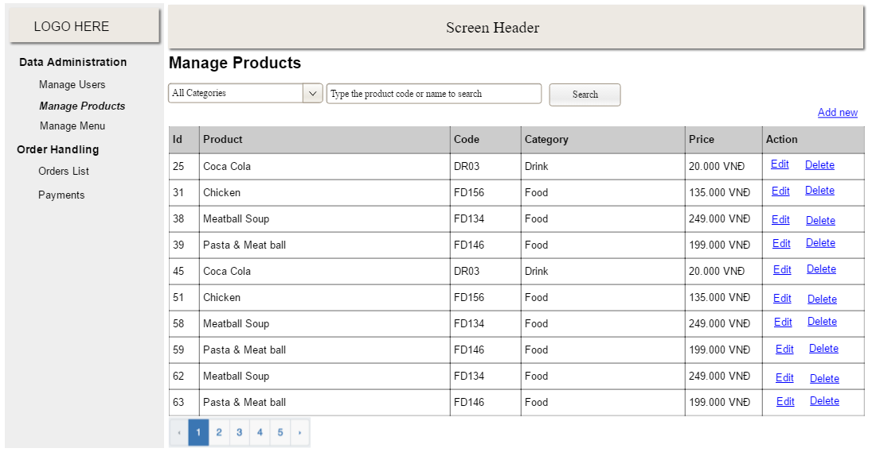

## 2. <<Feature Name 2>>